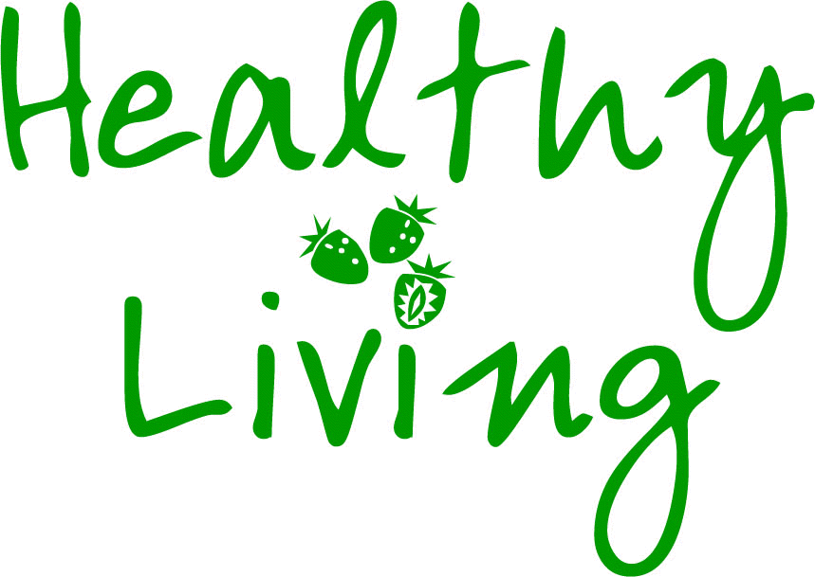The Life Audit 
INSTRUCTIONS:
Your group have been provided with four criteria that can be used to help individuals assess whether or not they lead a healthy life. Each criterion has been evidenced and in some cases additional notes have been provided.
As a group, your first task is to agree an additional criterion to make the total number to 5. You should do this by consensus and all members must agree with the additional criterion that you have developed.
Once the group have agreed the fifth criterion, turn over your sheet.
No. | Criterion | Notes | Evidence
1. | Adults should eat a minimum of five different portions of fruit and vegetables per day | A portion is classified as 80g weight and fruit smoothies/juice count as one portion. Potatoes do not count. | World Health Organisation, Department of Health and Food Standards Agency
2. | Adults should have an eye examination every 24 months |  | NHS Choices website
3. | Adults should not exceed drinking more than 14 units of alcohol per week | One unit is equivalent to:  Half a pint of beer, a small pub measure of spirits  One and a half units equate to:  A small glass of wine (125ml), a standard pub measure of spirits. | Chief Medical Officer
4. | Adults should work no more than 48 hours per week |  | European Union Directive
5.

The Life Audit – Personal Results
INSTRUCTIONS (part 2):
The next task for the group is to add a suitable question for criterion 5 that will enable learners to be able to assess if they are leading a healthy life. It may be useful to look at the other audit questions in order to help devise your question for criterion 5. Note: please try to phrase your question for criterion 5 in such a way that the positive/healthy response is ‘Yes’ (as this will make it consistent with the other four questions in the audit). Once question 5 has been added, all group members should record their own personal answers in the grid below. Upon completion of this part of the task, speak to your facilitator in order to obtain the next part of the task.
No. | Audit question | Notes | Yes/No
1. | Did you eat 5 or more different portions of fruit and vegetables yesterday? | A portion is classified as 80g weight and fruit smoothies/juice count as one portion. Potatoes do not count. | Yes / No
2. | Have you had an eye examination in the last 24 months? |  | Yes / No
3. | In the last seven days, has your alcohol intake been less or equal to the recommended intake of 14 units per week? | One unit is equivalent to:  Half a pint of beer, a small pub measure of spirits  One and a half units equate to:  A small glass of wine (125ml), a standard pub measure of spirits | Yes / No
4. | In the last seven days, have you worked 48 hours or less? |  | Yes / No
5. |  |  | Yes / No

