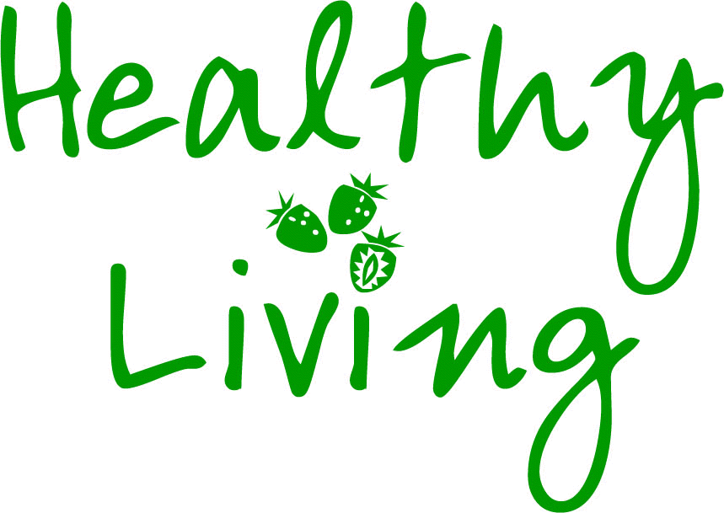The Life Audit – Group Results 
INSTRUCTIONS (part 3):
Once all group members have answered their own questions – the results need to be transferred onto the group results chart (see below). The chart should be passed from group member to group member so that results can be reported confidentially. Don’t forget to add in the details of the additional criterion that the group formulated (criterion 5).
Having completed the grid and totalled the number of ‘Yes’ responses for each criterion, the group must turn its attention to the criterion for which they scored least well (i.e. lowest number of ‘Yes’ responses). In the event of a tie for the lowest number of ‘Yes’ responses, the group can select which criterion they wish to focus on. The final part of the task is for the group to agree three action points (and record these overleaf), aimed at improving their lifestyle in respect of the criterion where they scored least well.
No. | Criterion | 1 | 2 | 3 | 4 | 5 | 6 | 7 | 8 | 9 | 10 | Total
1. | Adults should eat a minimum of five different portions of fruit and vegetables per day
2. | Adults should have an eye examination every 24 months
3. | Adults should not exceed drinking more than 14 units of alcohol per week
4. | Adults should work no more than 48 hours per week
5.

* Record Y/N on the grid to determine whether each criterion was met or not.

The Life Audit – Action Planning
INSTRUCTIONS (part 4):
The final part of the task is for the group to agree three action points (and record these below). The aim of the action planning stage is to come up with practical suggestions and recommendations that will help group members score better results if they were re-audited in 6 months time.
Criterion to be addressed: ____________________________________________

Action Point | Action to be implemented
1
2
3

