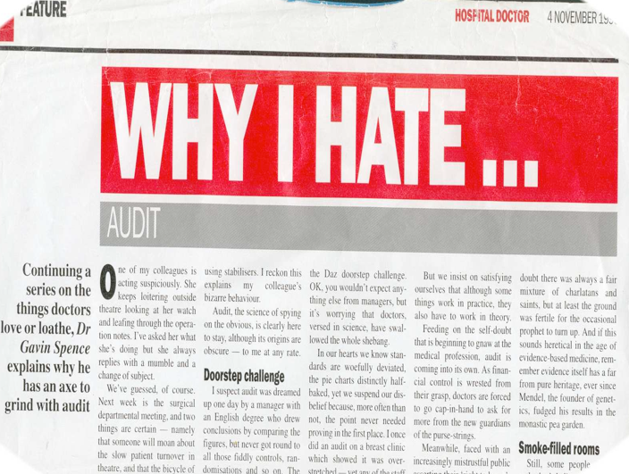

**RESOURSE 16: WHY I HATE … AUDIT**

One of my colleagues is acting suspiciously. She keeps loitering outside theatre looking at her watch and leafing through the operation notes. I’ve asked her what she’s doing but she always replies with a mumble and a change of subject.

We’ve guessed, of course. Next week is the surgical department meeting, and two things are certain – namely that someone will moan about the slow patient turnover in theatre, and that the bicycle of audit will once more wobble into view, pedalled by an SHO using stabilisers. I reckon this explains my colleague’s bizarre behaviour.

Audit, the science of spying on the obvious, is clearly here to stay, although its origins are obscure – to me at any rate.

**Doorstep challenge**

I suspect audit was dreamed up one day by a manager with an English degree who drew conclusions by comparing the figures, but never got round to all those tiddly controls, ran-domisations and so on. The result is that grass-roots NHS audit has all the credibility of the Daz doorstep challenge. Ok, you wouldn’t expect anything else from managers, but its worrying that doctors, versed in science, have swallowed the whole shebang.

In our hearts we know standards are woefully deviated, the pie charts distinctly half-baked, yet we suspend our disbelief because, more often than not, the point never needed proving in the first place. I once did an audit on a breast clinic which showed it was over-stretched – yet any of the staff who regularly stayed until 9pm could have told you that. But we insist on satisfying ourselves that although some things work in practice, they also have to work in theory.

Feeding on the self-doubt that is beginning to gnaw at the medical profession, audit is coming into its own. As financial control is wrested from their grasp, doctors are forced to go cap-in-hand to ask for more from the new guardians of the purse strings.

Meanwhile, faced with an increasingly mistrustful public asserting their ‘right to know’, we are beginning to stockpile the data behind which we can duck like wily politicians.

Apparently under siege, doctors are embracing the religion of audit to face off the persecution and have apparently sacrificed common sense at its altar.

We seem to have managed for the last few centuries without audit, but now we lack the confidence to trust our own judgment. Whatever happened to good old-fashioned conjecture and debate? Why does everything have to be translated into pseudo-science before we’ll listen to it?

Why, for example, did it take a surreptitious audit before the Department of Health woke up to the serious concerns surrounding paediatric cardiac surgery at the Bristol Royal Infirmary, when serious concerns had been an open secret there for months?

We come from a long tradition of individuals who kept their eyes open and wore their opinions on their sleeve. No doubt there was always a fair mixture of charlatans and saints, but at least the ground was fertile for the occasional prophet to turn up. And if this sounds heretical in the age of evidence-based medicine, remember evidence itself has a far from pure heritage, ever since Mendel, the founder of genetics, fudged his results in the monastic pea garden.

**Smoke-filled rooms**

Still, some people apparently don’t believe everything they read, even in a journal. I’m told some of the most enlightening moments at conference come in discussions with trusted colleagues in smoke-filled rooms at the end of the evening. Thank God for that. But there is one overriding reason I have for hating audit. It is intensely, mind-numbingly, ceaselessly and invariably dull. I defy anyone who claims otherwise. It bleeds the life out of controversy and, where imagination is concerned, it’s more sterile than a eunuch. What must the clinical auditors Christmas party be like?

Put it this way, if Ford produced a one-litre diesel saloon and called it the Audit, I wouldn’t be surprised. Neither would you, if you’re honest. And there’s the evidence if you still insist on it.

*Note: Dr. Gavin Spence is an MSc student, Royal National Orthopaedic Hospital, Stanmore and this document is based on his article published in Hospital Doctor magazine*